|  |  |
| --- | --- |
| **NAME** | SABARI S |
|  |  |
| **REGISTER NUMBER** | 812620243018 |
|  |  |
| **NM ID** | 860EA13909FA6DAB93445590D3FC2710 |
|  |  |
|  |  |
|  | **ASSIGNMENT - 3** |
|  |  |

|  |  |  |  |  |
| --- | --- | --- | --- | --- |
|  | **1.** | **Download the dataset: Dataset** | |  |
|  | **2.** | **Load the dataset.** | |  |
|  | **3.** | **Perform the Below Visualizations.** | |  |
| **Tasks** |  | **●** | **Univariate Analysis** |  |
|  | **● Bi - Variate Analysis** | |  |
|  |  |  |
|  |  | **●** | **Multivariate Analysis** |  |
|  | **4.** | **Perform descriptive statistics on the dataset.** | |  |
|  | **5.** | **Handle the Missing values.** | |  |
|  |  |  |  |  |

1. **Download the dataset.**
2. **Load the dataset.**
3. **Perform the Below Visualizations.**

**Univariate Analysis**

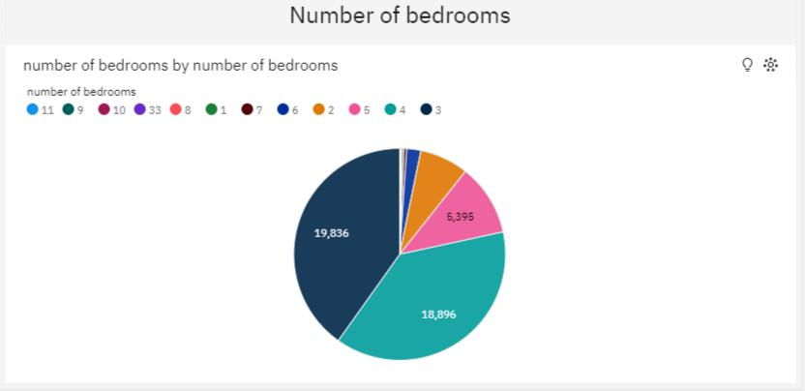

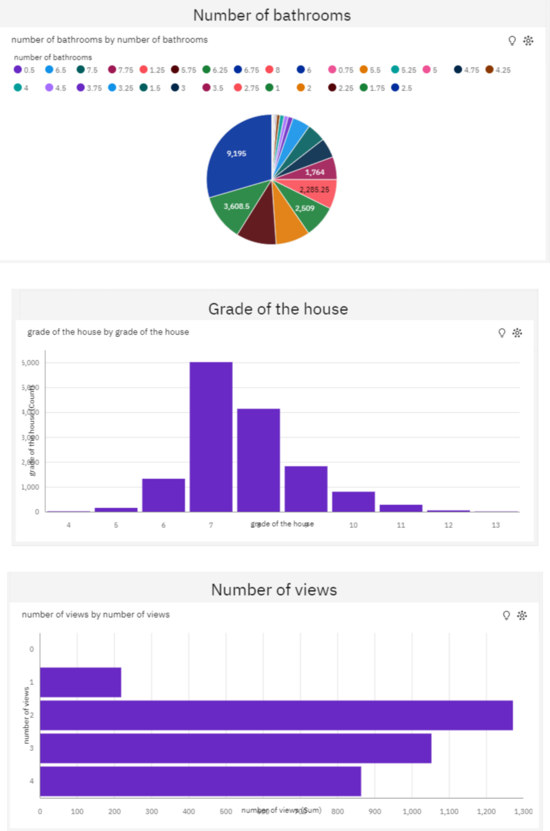

**Bi - Variate Analysis**

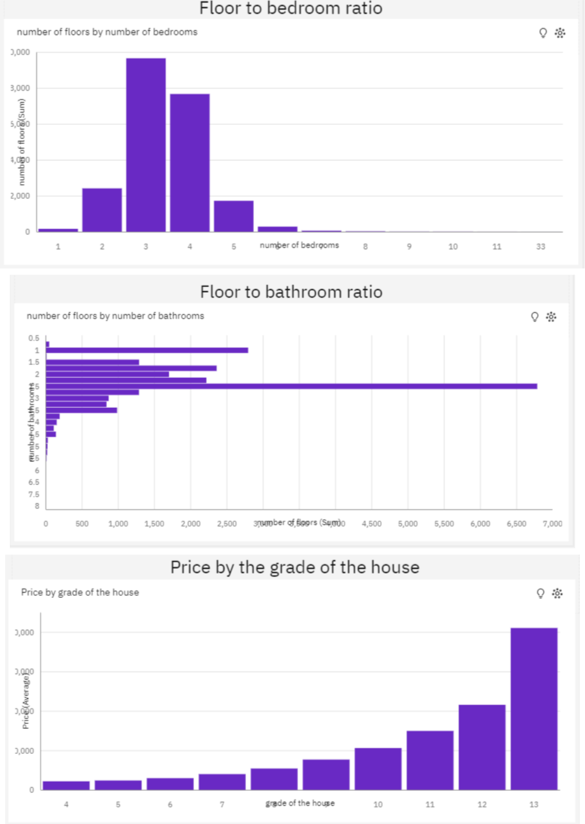

**Multivariate Analysis**

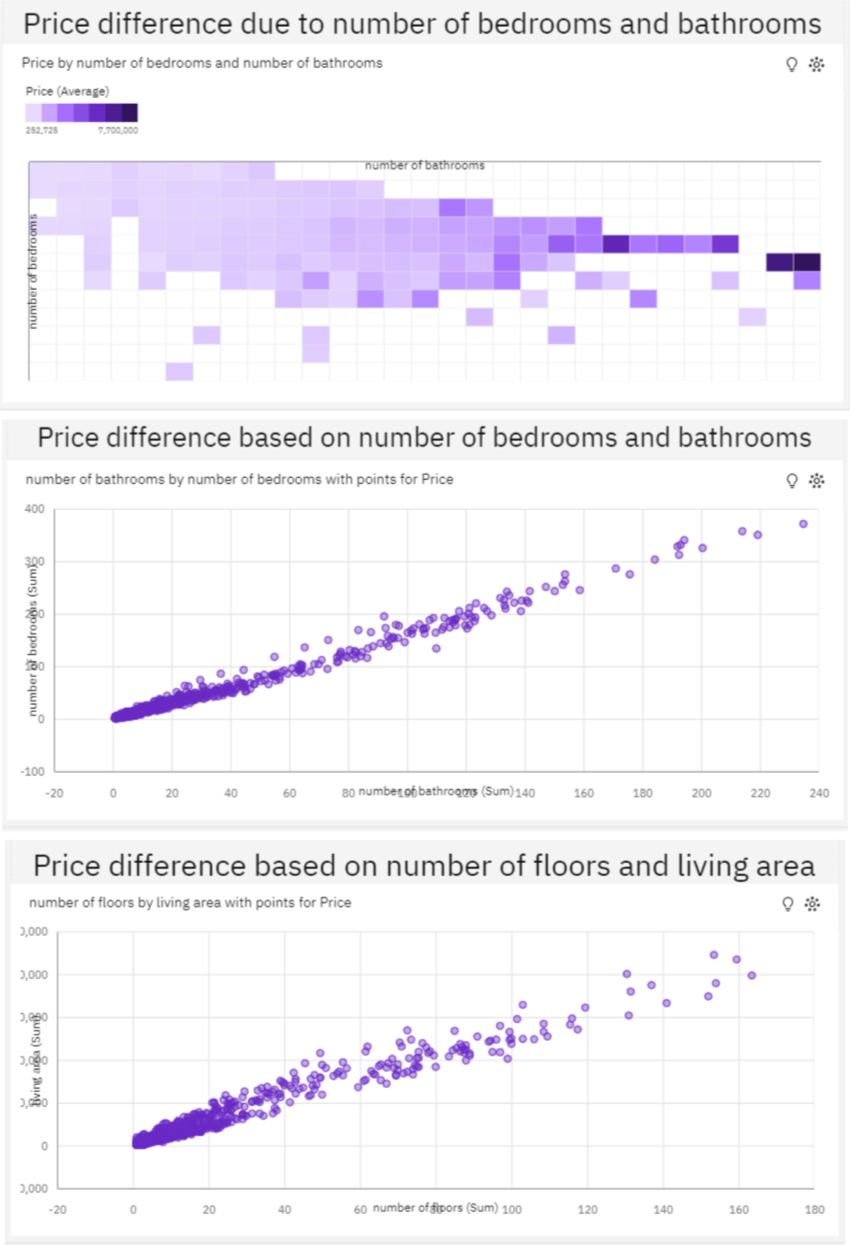

**4. Perform descriptive statistics on the dataset.**

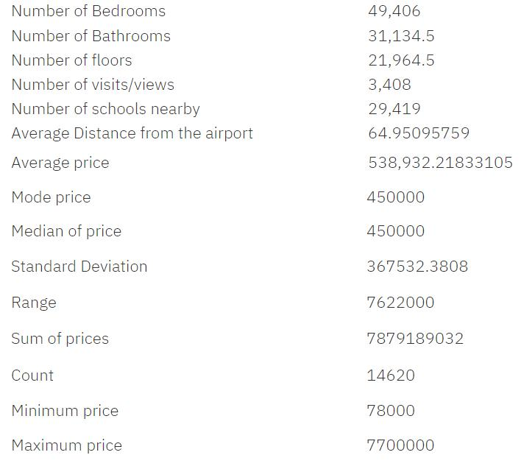

**5. Handle the Missing values.**

No missing values in the dataset.